ELECTRONICS TASK-4

PALAK CHHAPARWAL  
MECHATRONICS  
MIT MANIPAL  
KARNATAKA INDIA   
[palak1.mitmpl2024@learner.manipal.edu](mailto:palak1.mitmpl2024@learner.manipal.edu)

# DC ANALYSIS OF RESISTOR CIRCUIT

## INTRODUCTION

The circuit containing only a pure resistance of R ohms in the AC circuit is known as the Pure Resistive AC Circuit. The presence of inductance and capacitance does not exist in a purely resistive circuit.

The resistor is a passive device that neither produces nor consumes electric power. It converts the electrical energy into heat.

## ANALYSIS OF THE CIRCUIT:

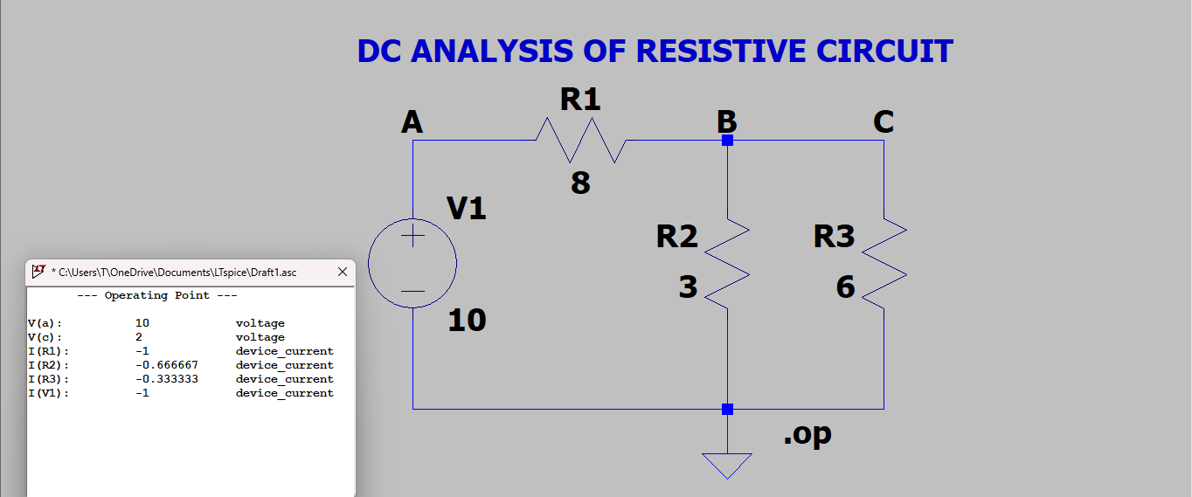POINTS TO BE NOTED:

* The current flowing through the voltage source is -1 the negative sign implies that the current enters from the positive terminal. The software uses a passive sign convention due to which the negative sign appears.
* The current flowing through R1 is -1 which implies the current flows from node B to node A.
* The voltage drops across R2 and R3 are positive. So current flows from node B to ground.

# AC ANALYSIS OF PASSIVE FILTER

## INTRODUCTION:

A Low Pass Filter is a circuit that can be designed to

modify, reshape, or reject all unwanted high frequencies of an electrical signal and accept or pass only those signals wanted by the circuit designer. Here, focusing on the analysis of a low-pass filter.The Low Pass Filter – the low pass filter only allows low-frequency signals from 0Hz to its cut-off frequency, ƒc point to pass while blocking those any higher. The frequency at which the transition occurs is called the “cut-off” or “corner” frequency. The cutoff frequency is the point at which the signal begins to attenuate. At this frequency, the gain is reduced to -3 dB, which corresponds to approximately 70.7% of the input signal amplitude.

## THE USUAL GRAPH

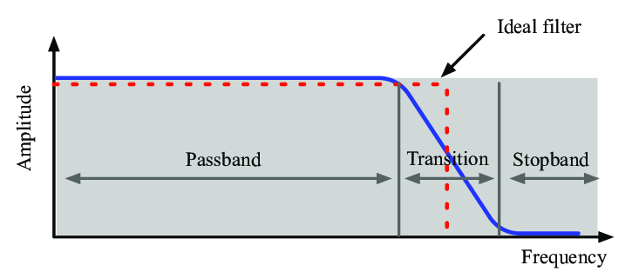

## ANALYSIS OF GRAPH

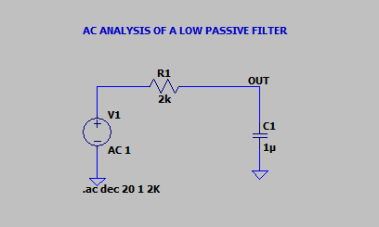

POINTS TO BE NOTED:

* The solid blue line represents the gain (magnitude) in decibels (dB) versus frequency on a logarithmic scale (x-axis). Gain decreases as the frequency increases, indicating that this is likely a low-pass filter, which allows low frequencies to pass through while attenuating higher frequencies.
* The dashed blue line represents the phase shift (in degrees) versus frequency.
* At 79.83 Hz, at approximately -3.03 dB is close to the cutoff frequency of the filter. At this frequency, the signal power is reduced to half its maximum value. The phase shift at this point is -45 degrees.

# TRANSIENT ANALYSIS OF RC CIRCUIT CHARGING:

## INTRODUCTION:

A transient RC circuit involves a resistor (R) and a capacitor (C) and describes the behavior of the circuit when it transitions from one steady state to another, particularly during the charging or discharging of the capacitor.

Behavior:

Charging: When a voltage is applied to an uncharged capacitor through a resistor, the capacitor begins to charge. The voltage across the capacitor increases gradually, not instantly.

Discharging: When the capacitor discharges through a resistor, the voltage across the capacitor decreases gradually.

Time Constant: The time constant is the time it takes for the voltage across the capacitor to reach approximately 63.2% of its final value during charging or to fall to about 36.8% of its initial value during discharging.



Charging Equation:

The voltage across the capacitor at time tt during charging is given by:



## ANALYSIS OF CIRCUIT:

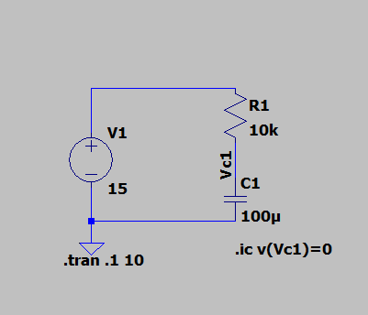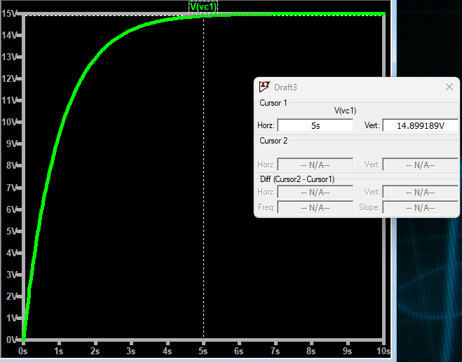Points to be noted:

1. X-Axis (Time in seconds): The horizontal axis represents time, measured in seconds (from 0 to 10 seconds).

2. Y-Axis (Voltage in volts): The vertical axis shows the voltage across the capacitor, ranging from 0V to 15V.

3. Curve Behavior: The voltage starts at 0 V. As time progresses, the voltage rises rapidly at first and then slows down, approaching a maximum voltage of 15 V at 5 secs then has constant voltage.

The time constant of the given circuit is 1. This curve shows the charging of a capacitor.

# Op-Amp Inverting and Non-Inverting Amplifiers

## INTRODUCTION:

In the inverting operational amplifier circuit, the signal is applied at the inverting input and the non-inverting input is connected to the ground. In this type of amplifier, the output is 180⁰ out of phase to the input, i.e. when positive signal is applied to circuit, the output of the circuit will be negative.

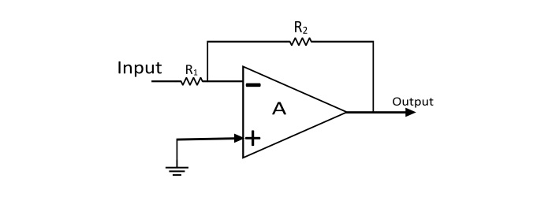When the signal is applied at the non-inverting input, the resulting circuit is known as Non-Inverting Op-Amp. In this amplifier the output is exactly in phase with the input i.e. when a positive voltage is applied to the circuit, the output will also be positive.

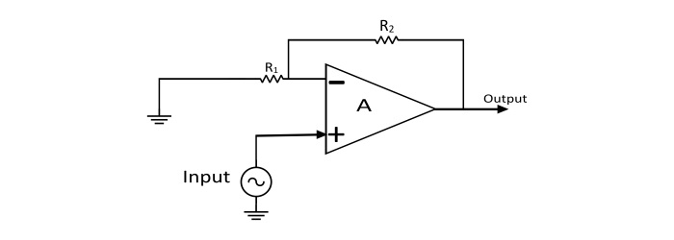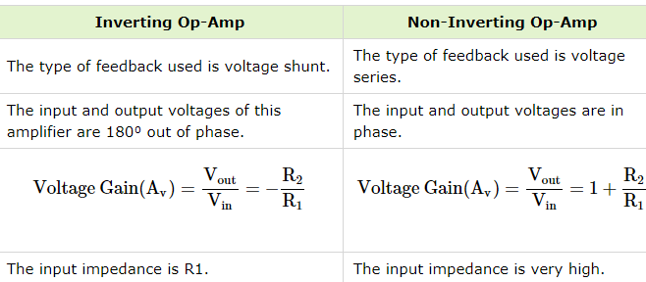

## CIRCUIT ANALYSIS:

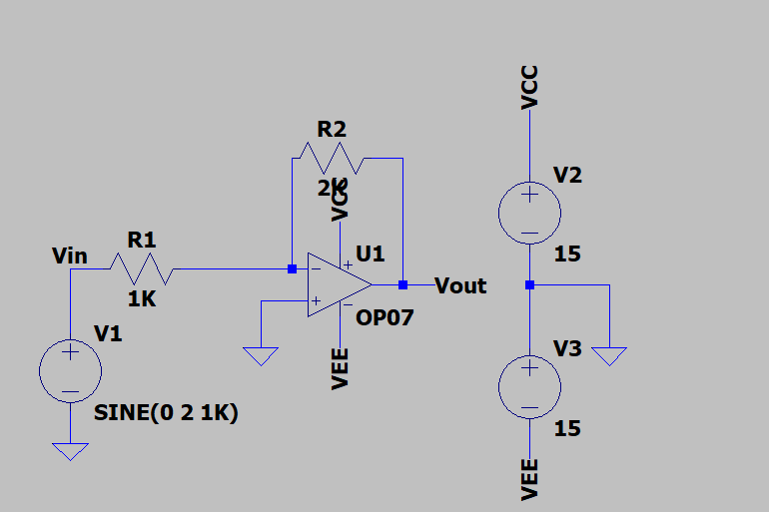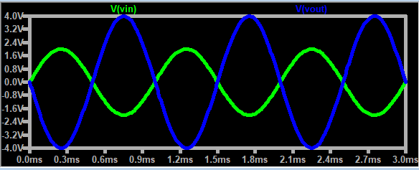The following way from is of an OP AMP inverting amplifier. The blue line represent the output voltage and the green line represents the input voltage. The face shift between both of them is 180° and you can see that the gain is around two, which can be calculated from the above formula. Vcc and Vee represent the power supplied to op amp.

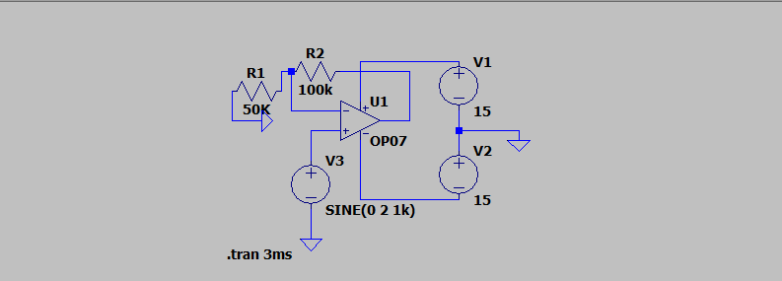

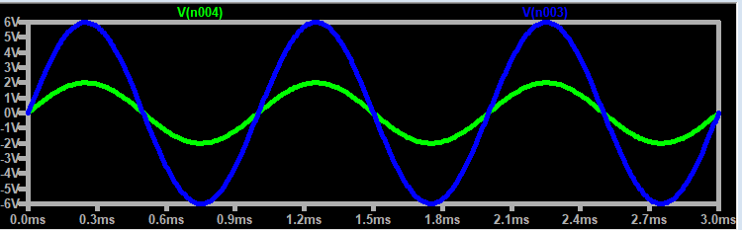The following waveform is of OP-AMP noninverting amplifier hear the blue line represents the output voltage and the green line represents the input voltage as you can see the gain is about three which can be calculated from the above formula. It is to be noted that, unlike the inverting amplifier, the phase difference here is zero. V1 and V2 represent the voltages for the OP. It is to be noted that here the input voltage is attached to the non-inverting terminal.

# Simulation of a Full-Wave Rectifier

## INTRODUCTION

Rectifier diodes allow current to flow in only one direction, from anode to cathode, also called Forward Bias. When the positive terminal of the power supply is with the cathode and the negative terminal with the anode, the diode is Reverse Biased and hence no current passes through them.

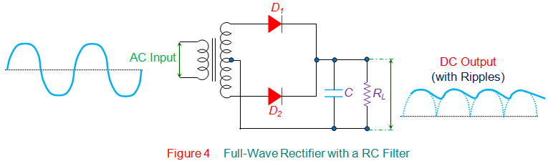

## ANALYSIS OF CIRCUIT

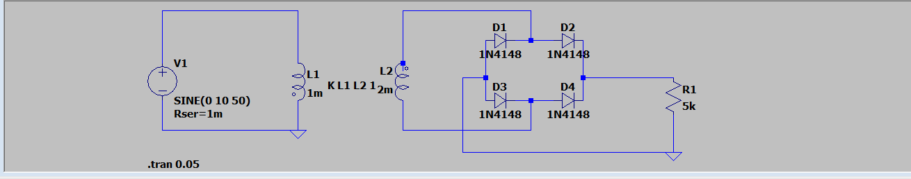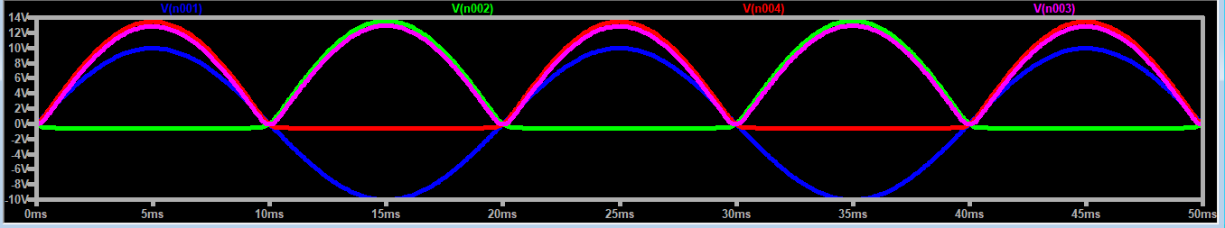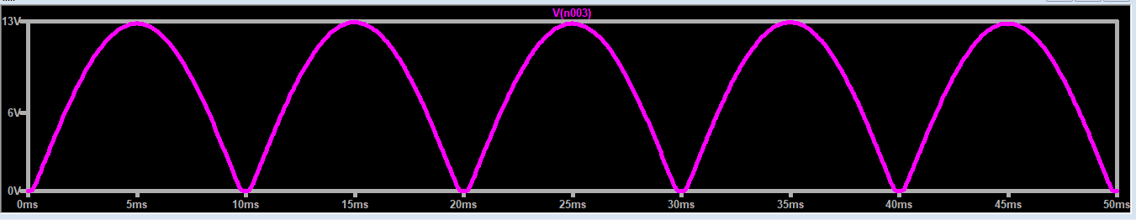Points to be noted:

The blue line represents the input voltage , red and green represent the half cycles and the pink one represents the output voltage.

This is without addition of a filter here we can see that output voltage returns to zero and then again rises hence the efficiency is low.

After adding the filter i.e. the capacitor

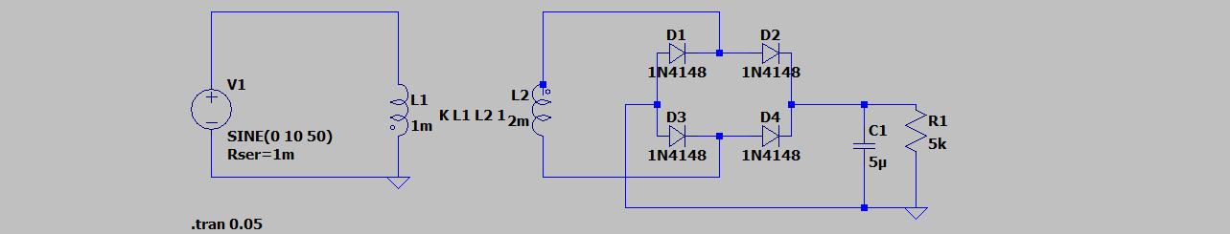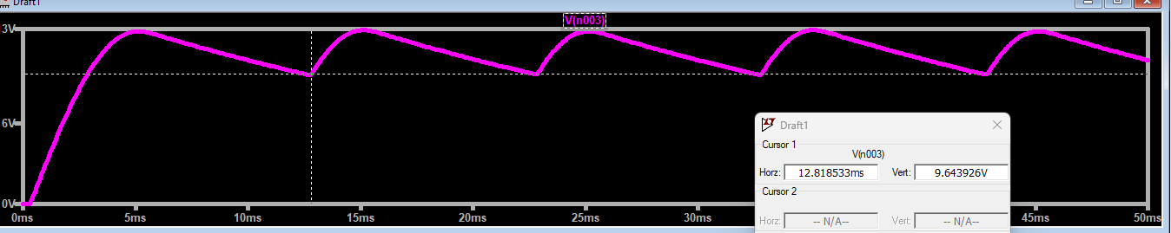As we can observe the voltage only drops to 9.64 approx thus increasing the efficiency further.

# TRANSIENT RESPONSE OF SECOND ORDER SYSTEM:

## INTRODUCTION

Known as second-order circuits because their responses are described by differential equations that contain second derivatives.

## CIRCUIT ANALYSIS:

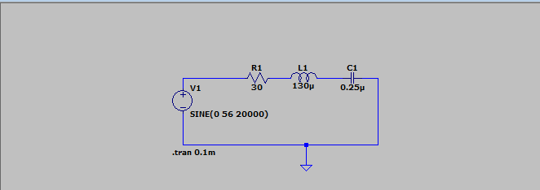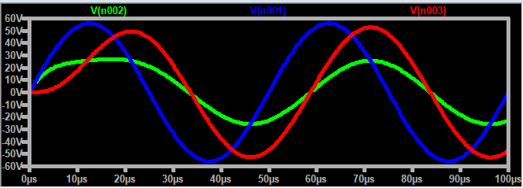The circuit consists of a resistor R1 = 30 Ω, inductor L1 = 130 µH, and capacitor C1 = 0.25 µF. A sinusoidal AC voltage source V1 is applied: SINE (0 56 20000), which specifies a peak voltage of 56V with a frequency of 20 kHz. Second-order circuits like this are characterized by oscillatory responses or damped oscillations due to the combined effect of inductance and capacitance.

The blue line represents the total voltage. Red represents a voltage drop across the capacitor and green represents a drop across the inductor.

# ANALYSIS VOLTAGE REGULATOR

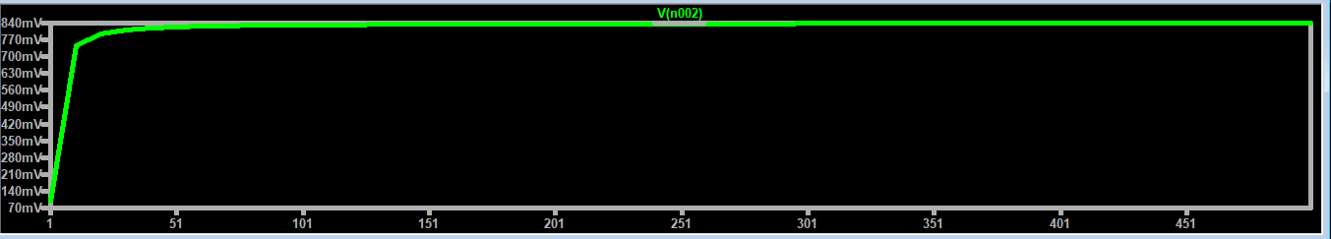The circuit includes:

V1: A 10V DC voltage source.

R1: A resistor with a default value of 100 Ω.

R2: A variable resistor parameterized using .step command.

D1: A diode (1N4148) connected in series with the resistors.

The simulation analyzes how the voltage at the diode changes with different resistance values of R2

The voltage increases quickly initially, then levels off, indicating the diode's forward voltage drop and the resistive network's influence.

# FREQUENCY RESPONSE OF AMPLIFIER

## INTRODUCTION

The frequency response of an amplifier describes how the gain (amplification) of the amplifier varies with the frequency of the input signal. It is typically represented as a graph of gain versus frequency.

Key Regions:

Low-Frequency Region: At low frequencies, the gain of the amplifier may decrease due to the effects of coupling and bypass capacitors. These capacitors can block low-frequency signals, leading to reduced gain.

Mid-Frequency Region: In this region, the amplifier operates with a relatively constant gain. This is the desired operating range where the amplifier performs optimally.

High-Frequency Region: At high frequencies, the gain of the amplifier may again decrease due to the internal capacitances and inductances of the components. These effects can cause the amplifier to attenuate high-frequency signals.

Bandwidth: The bandwidth of an amplifier is the range of frequencies over which the amplifier maintains a relatively constant gain. It is typically defined by the frequencies at which the gain drops by 3 dB from its maximum value (the -3 dB points).

Cutoff Frequencies:

Lower Cutoff Frequency: The frequency below which the gain starts to decrease significantly.

Upper Cutoff Frequency: The frequency above which the gain starts to decrease significantly.

Gain-Bandwidth Product: This is a constant for a given amplifier and is the product of the amplifier's bandwidth and its gain. It is an important parameter for determining the performance of the amplifier at different frequencies

## CIRCUIT ANALYSIS:

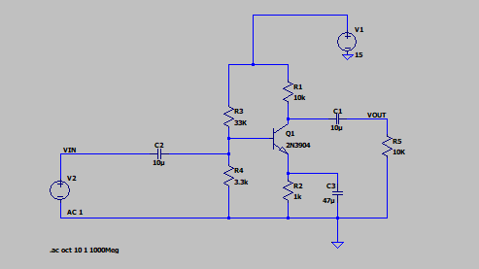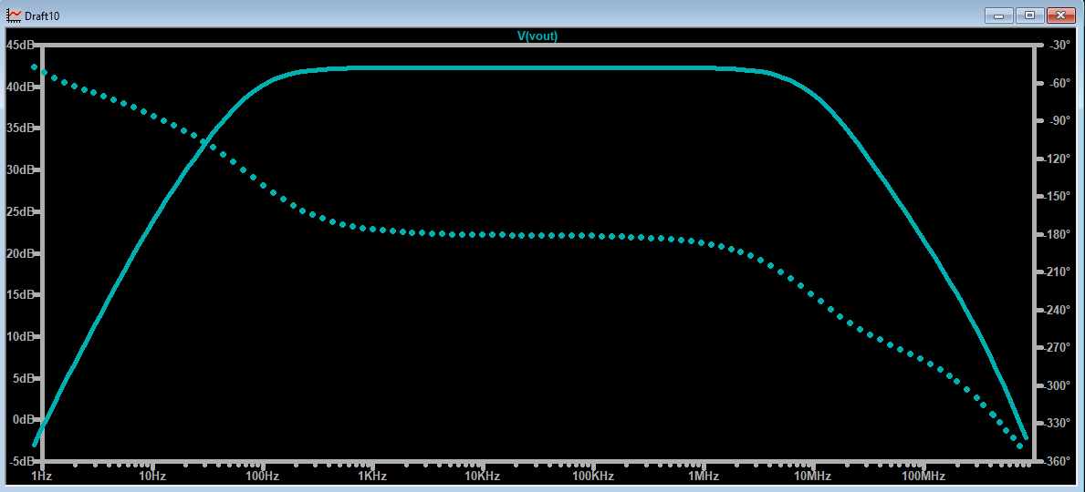The amplifier's gain decreases at both low and high frequencies, indicating its bandwidth-limited behavior.

The mid-band region (flat part) shows a stable gain, typical for a CE amplifier in its passband.

The amplifier has a clear mid-band gain where it behaves as expected.

Bandwidth is limited at both low and high ends, showing low-frequency cut-off and high-frequency cut-off points.

This frequency response is typical for CE amplifiers, where the gain-bandwidth product remains constant.

# SIMULATION OF WEIN BRIDGE

## INTRODUCTION

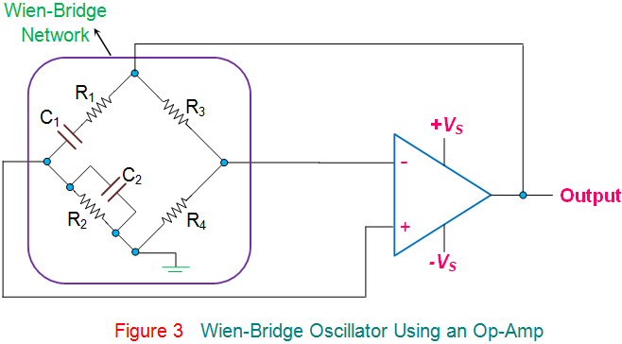It will produce sinusoidal oscillations, which will be in the range of audio. Frequencies it is very stable in producing the output frequency and produces frequency in the range of 1 MHz. The circuit consists of an RC combination where R1, R2, and capacitors C1 and C2 form the frequency adjustment elements. The series combination of C1 and R1 and the parallel combination of C2 and R2 will allow only one frequency component. The resistors R3 and R4 form part of the feedback path. rearranging the part combination of R1 and C1 and a parallel combination of R2 and C2 will form the RC network, which will act as the feedback part of the circuit. thermal noise consists of multiple frequency feedback networks that should select only one frequency component to get the sustained oscillation. Observe the network. A combination of R1 and C1 will act as a high pass filter and a parallel combination of resistors R2 and C2 will act as a low pass filter. Hence the combination will allow only one intermediate frequency Output.

At high frequencies circuit behaves like lag circuit and the reactance of the parallel capacitor, (C2) turns out to be exceptionally low, so this capacitor acts like a short circuit across the output, so there is no output signal.

At low frequencies circuit behaves like lead circuit and the reactance of the series capacitor (C1) becomes exceptionally high , it act as an open circuit, blocking the input signal produces no output signal.

The frequency of the input waveform at which output voltage reaches its maximum value (in between C1 being open-circuited and C2 being short-circuited ) is called the Resonant Frequency.

At resonant frequency, the circuit’s reactance( XC) equals to its resistance( Xc = R), and the phase difference between the input and output equals zero degrees (0°).

The magnitude of the output voltage at its maximum is equal to 3 or more times the input voltage which is taken as Voltage gain (AV ).

## CIRCUIT ANALYSIS

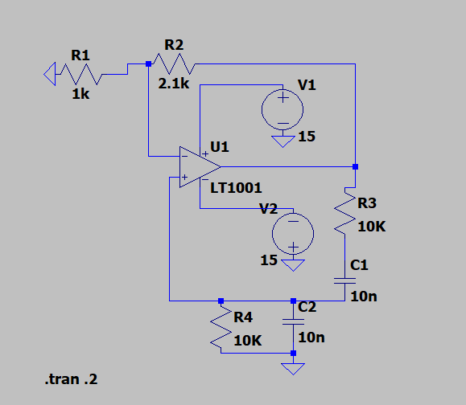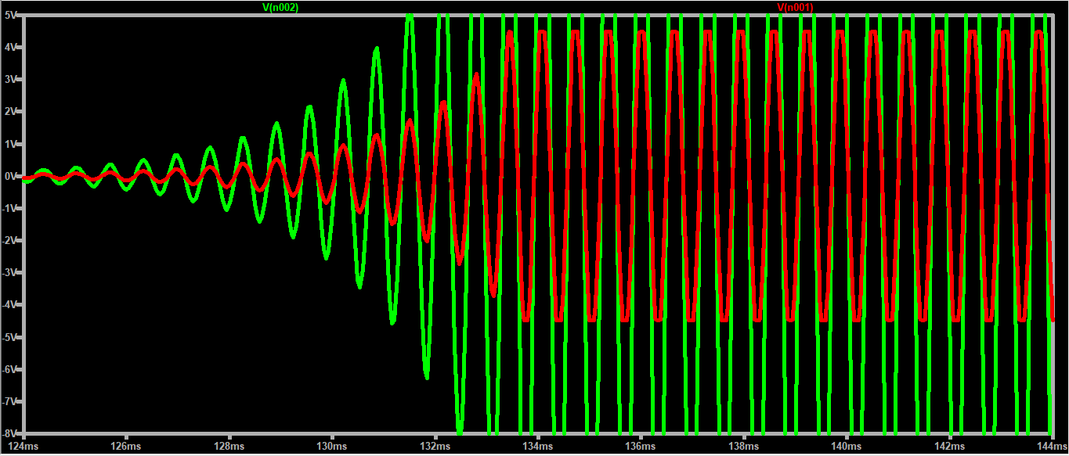The following can be observed;

The red waveform represents the input and green represents the output. The gain here is roughly 3 times.

# ANALYSIS OF VOLTAGE DIVIDER

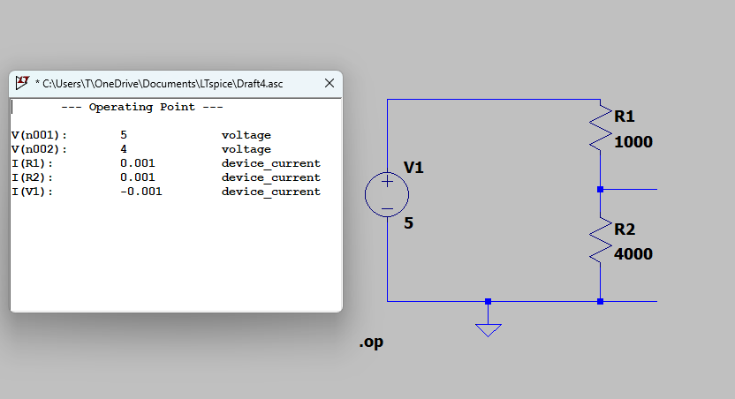POINTS TO BE NOTED:

The above circuit follows voltage division rule which states that voltage across R1 and R2 can be given be



